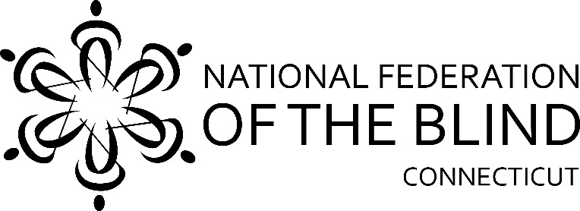

**50th Annual State Convention!!**

**Celebrating our Past, Present & Future**

**The National Federation of the Blind of Connecticut will hold our 50th Annual State Convention on Friday, Saturday, and Sunday, October 29, 30 and 31, 2021** at the **Sheraton Hartford South, 100 Capital Boulevard, Rocky Hill**. **The Sheraton Hartford South has a mask mandate for all attendees whether vaccinated or not.** Rooms will be available for Friday and Saturday nights for a convention discounted rate of $99.00, plus tax, per night. **To reserve a room, call the Sheraton Hartford South at 860-257-6000 and mention that you are attending the National Federation of the Blind of CT State Convention.** **The deadline for reserving a room for the convention is October 6, 2021. Our Convention will also be held on Zoom for those not comfortable meeting in person yet. The link will be on our website closer to the event.**

We will kick things off Friday evening at 5:00pm with a cash bar, a Mashed Potato Bar and a Slider Station, followed by a Variety Show organized by At-Large President Jim Cronin.

On Saturday morning, a continental breakfast starting at 8:00am will be followed by our general session which starts promptly at 9:00am. We will hear from Affiliate President Maryanne Melley and our National Representative followed by a variety of new and innovative speakers.

A boxed lunch will be served from 12pm-1:00pm. Speakers will continue and there will be a Vendor Fair From 1:00pm-4:00pm.

Our Banquet will begin at 6:00pm. Our National Representative will address our convention during the banquet Saturday evening. Also, we will present Academic Scholarship Awards.

We will, of course, have our 50/50 raffle!

On Sunday morning at 8:00am, a continental breakfast will be served before our 9:00am Annual Business Meeting. We will elect two board positions, and the secretary position for a one-year term.

**The National Federation of the Blind of Connecticut acknowledges**

**with gratitude our convention sponsors listed below:**

cid:c73e389a-6d52-47a1-9779-f3cb89fe08dd@vandapharma.com

**vandapharma.com**

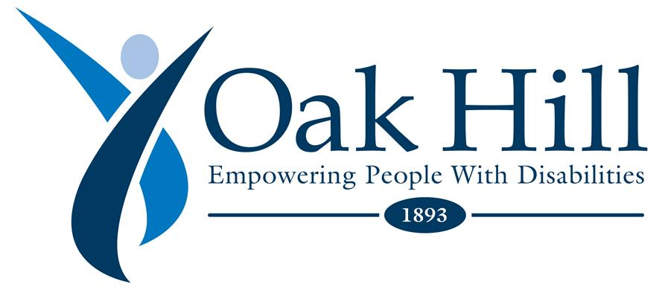

[**www.oakhillct.org**](http://www.oakhillct.org)

**Youthful Images, Bloomfield, CT**

**Retina Consultants, PC, Manchester, CT**

**Registration Form**

Attendees who register at the door will be charged an additional $10. **Please remember that the Sheraton Hartford South has a mask mandate whether or not attendees are vaccinated.**

**Name**: ______________________________________________________

**Address**: _____________________________________________________

**Phone**: ______________________________________________________

**E-mail**: ______________________________________________________

**Indicate how many will be attending the following:**

**Division meetings Saturday Afternoon**

_____ CT Association of Guide Dog Users; _____ CT Association of Blind Student

_____ Full convention package, $75 per person. Includes Saturday and Sunday breakfasts, Saturday lunch and banquet dinner.

_____ Saturday Morning Continental Breakfast, $15

_____Saturday Boxed Lunch: ____Turkey Club, $20; ____Grilled Buffalo Chicken Caesar Wrap, $20; ____Vegetarian Southwest Wrap, $20

_____ Saturday Night Banquet: Salad Choice: ____Caesar Salad; ____Garden Salad

Meal Choice: ____Chicken Picatta with lemon and capers, $35; or Pasta Primavera, $33

______Sunday morning continental Breakfast, $15

**______ No, I cannot attend the 2021 state convention, but I am sending a donation to the NFB of CT.**

**Registration deadline is October 15th**. Send your check payable to the NFB of CT with your registration form to:

**NFB of CT, 111 Sheldon Road, Unit 420, Manchester, CT 06045**